Time Series : create a model to forecasting(predicting into the future) from Timeseries data.
- Time Series Components :
Trend – positive or negative trend in long term overall data
Seasonality – seasonal changes in data in regular time period.
Cycle – changes of data in a cycle, not regular time.
Variance – if not fall in the above group, just flatter as noise.

- Stationary Data– Removed trends, seasonal and cyclic changes and make mean and standard deviation constant throughout the period.
Stationarity ensures mean and variance are constant and not fluctuated.
Before build model whether data is stationary or non-stationary has bee checked using hypothesis testing of Augmented Dickey-Fuller (ADF) test or the Kwiatkowski-Phillips-Schmidt-Shin (KPSS).
H0 – Data are non-stationary. H1- Data are stationary. (significance level of 0.05)
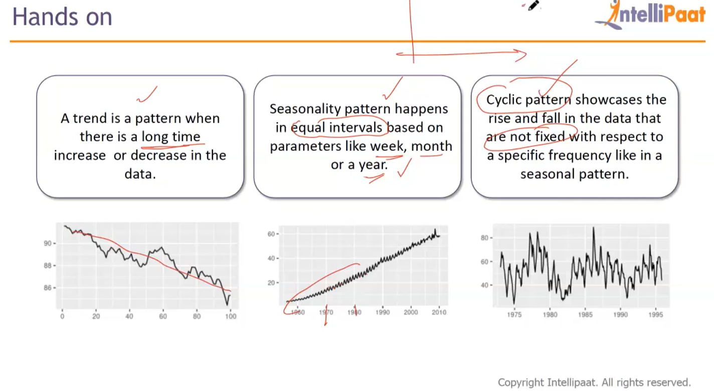
Step-by-step crate time series model :
- Analyse time series data : calculate rolling mean and standard deviation and plot the data with them:
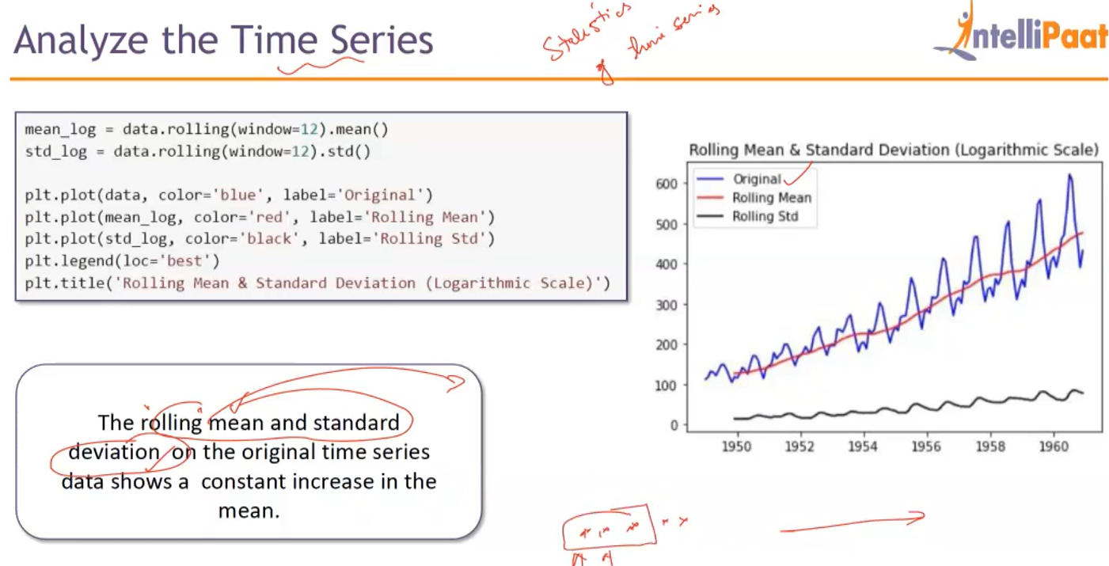
Increase the window size in rolling mean, smoothing the rolling mean(moving average) i.e reduce the fluctuation( see the fluctuation in first graph:
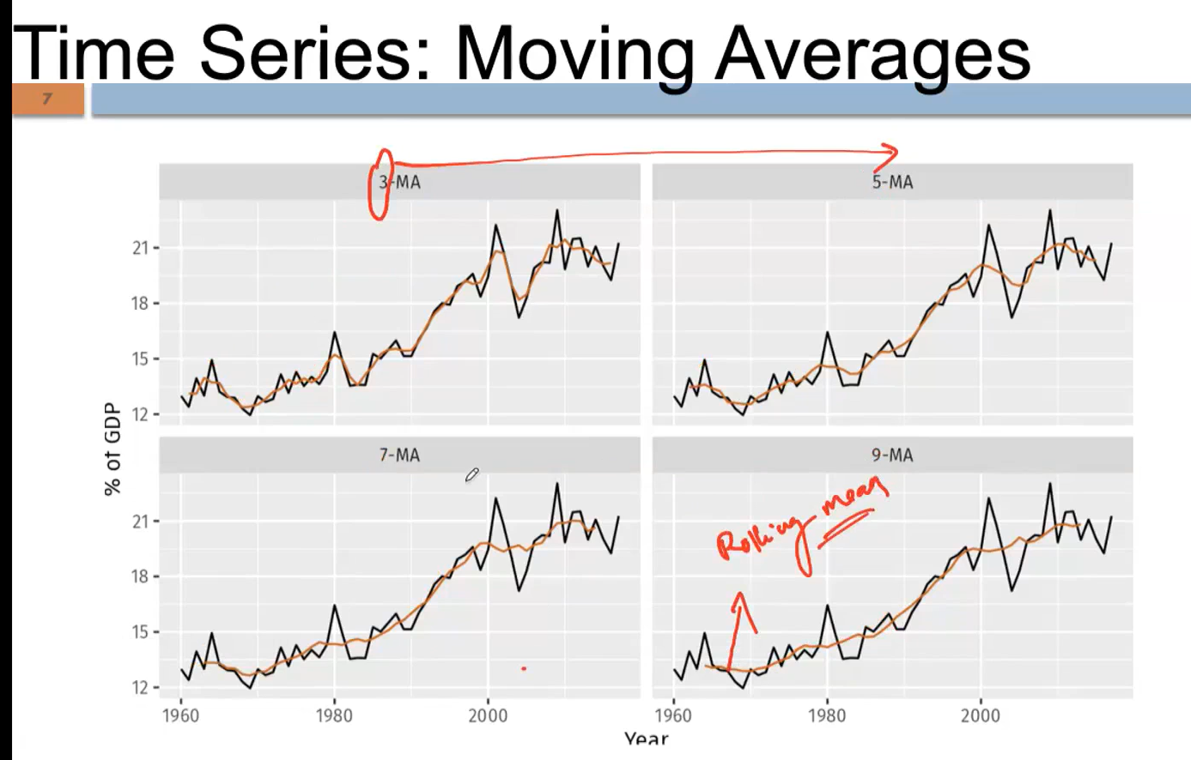
- check data is stationary : i.e. data has no trends, seasonality and cyclic behavior. Using ADF statistical test can find stationarity in time series data.
So set, H0 – Data are non-stationary. H1- Data are stationary (significance level of 0.05) and do the ADF statistical test:
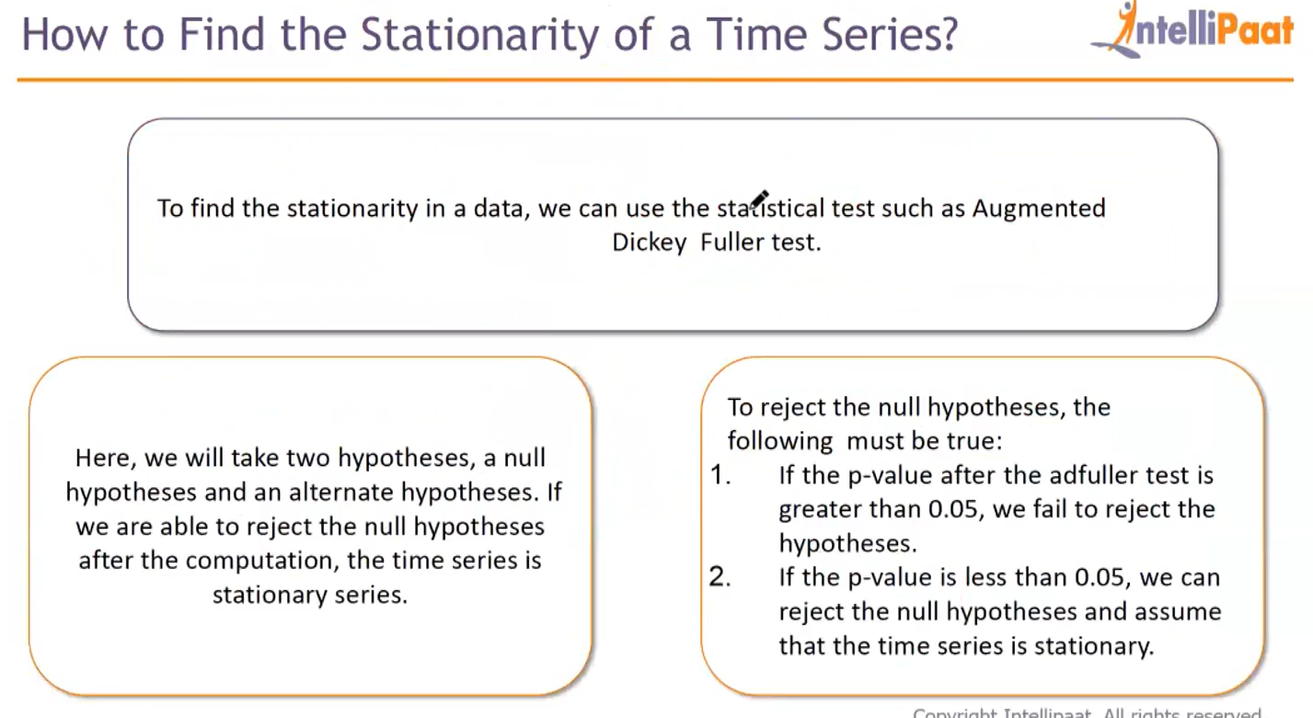

#checking the stationarity
from statsmodels.tsa.stattools import adfuller
result=adfuller(data['#Passengers']); print(result[1]) # p-value
- Remove stationarity (in various way):
- Differencing : common way, subtract the current value from lagged value. diff(t) = yt – yt-1. This will stabilize the mean(constant across data), so it will remove the trend. The value may negative if negative trend.

Google data see how differencing removes the trend , rolling mean become the constant: [ diff = currentday-previousday] :
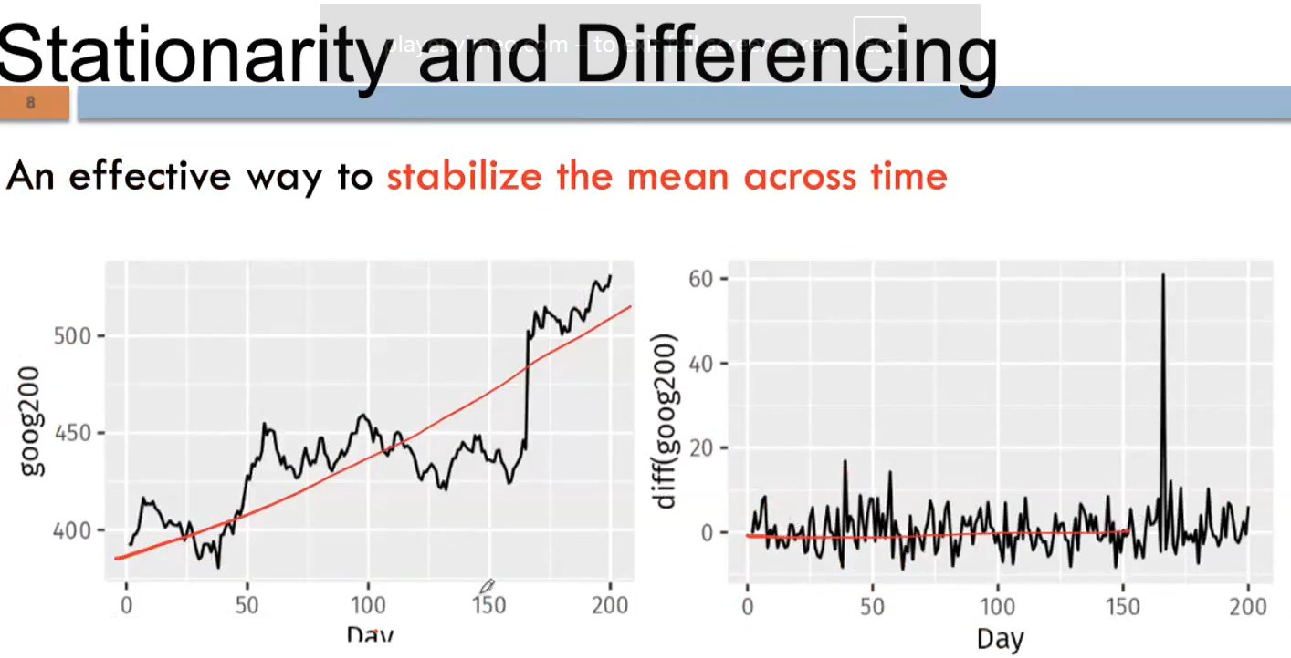
if first-order differencing not removes the trend (or not stabilize the mean) , have to go with second-order differencing(second prime), may go with nth order differencing until stabilize mean: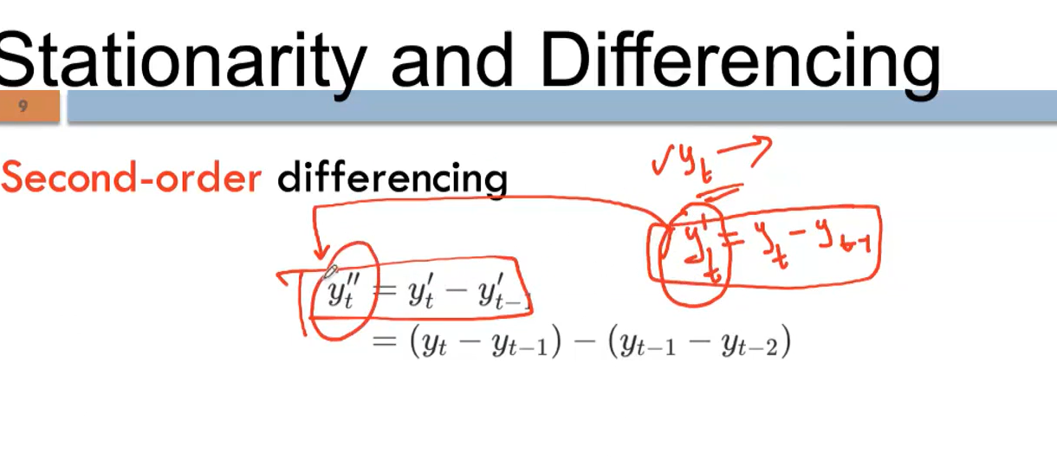

- Power transformation and Log transformation methods: stabilize the variance across time:
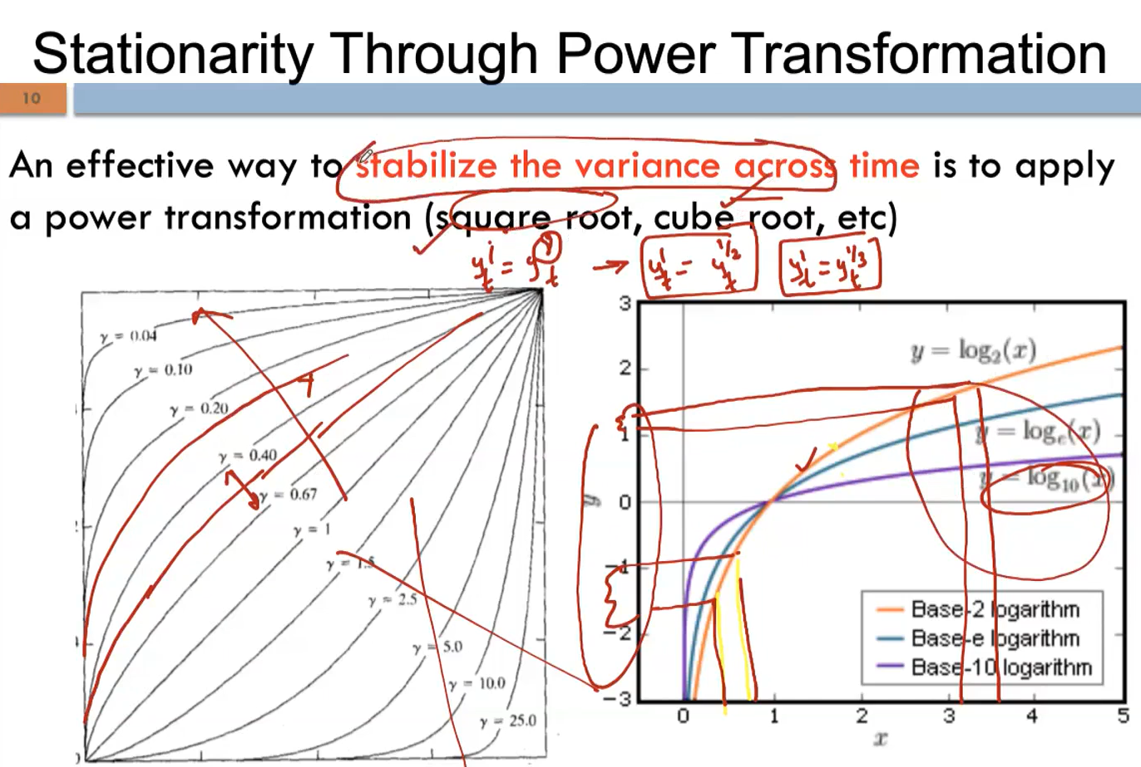
small value expanded in o/p, larger value compressed in curve: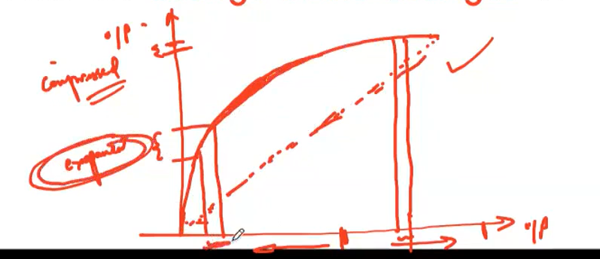
in below plots, can see variance has been stabilized(2nd plot) , because of the nature of power transformation, i.e, expand the small value larger, and compressed the large values:
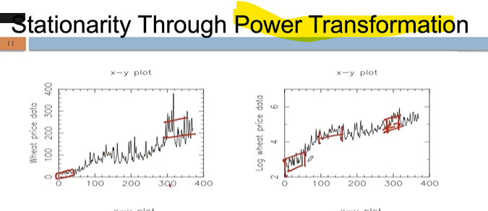
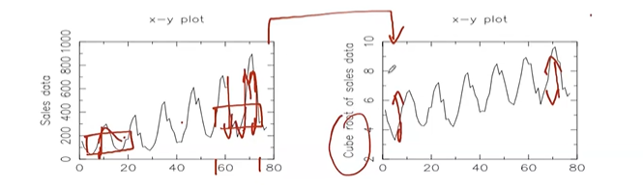

In below, first go with log to stabilize the variance (std.dev) , further differencing to remove the trend (i.e. stabilize the Moving Average), further done 12th order differencing (seasonal differencing , here every 12th month the seasonal change occurred) to remove the seasonality to reach stationarity:
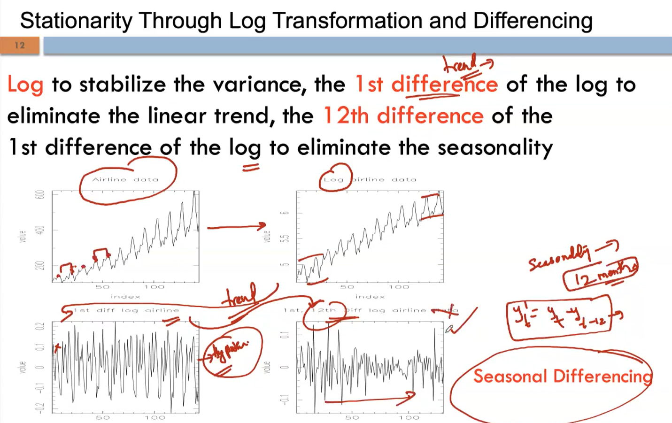
- Apply transformation and differencing in sample data:
After log transformation , plot the data, could see still moving average is not constant, but standard deviation is stabilized compare to original data:

Original data (before log transformation):
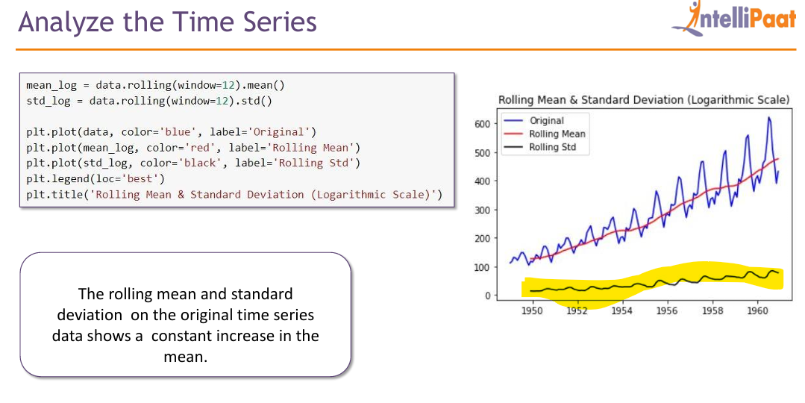

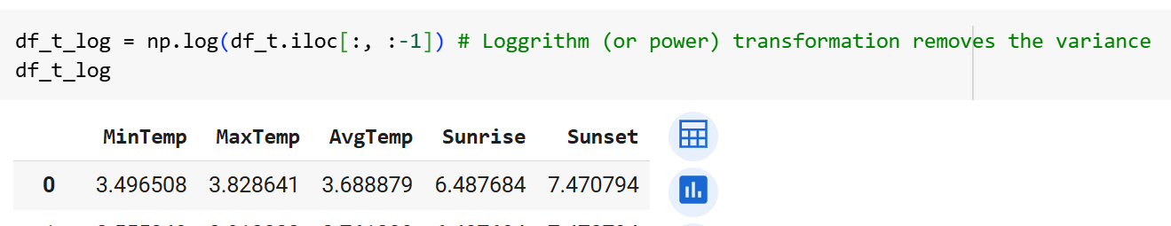

Plot after log transformation:
Standard deviation (black line) well stabilized, but still rolling mean is not constant.
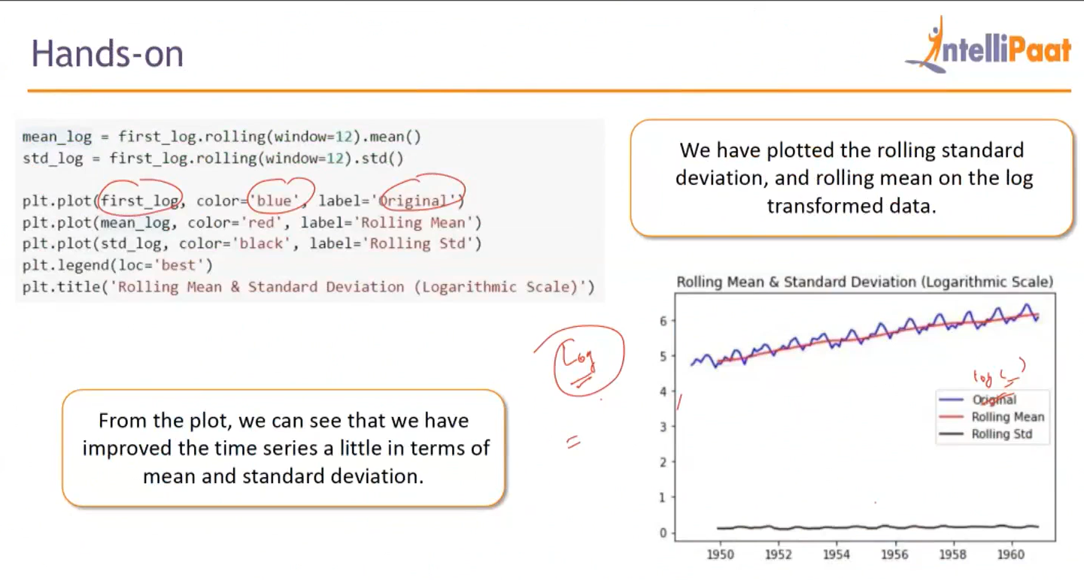

So now differencing need to be applied to remove trend : as an alternative in differencing we can reduce value from mean to get differencing data, as like below.
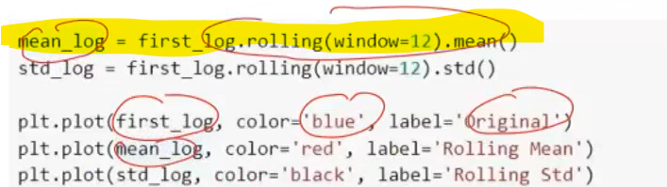
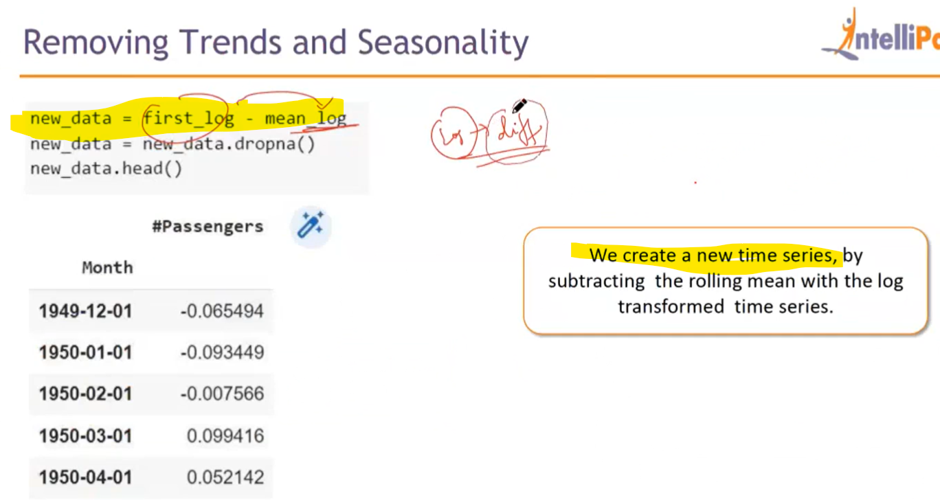
After differencing we could see std.dev(variance) and mean are better. (note, the plot is in reduced scale in y-axis, do not overlook as its still fluctuated) : now the new_data is almost stationary , we could check the hypothesis testing it will less than 0.5 the p-value.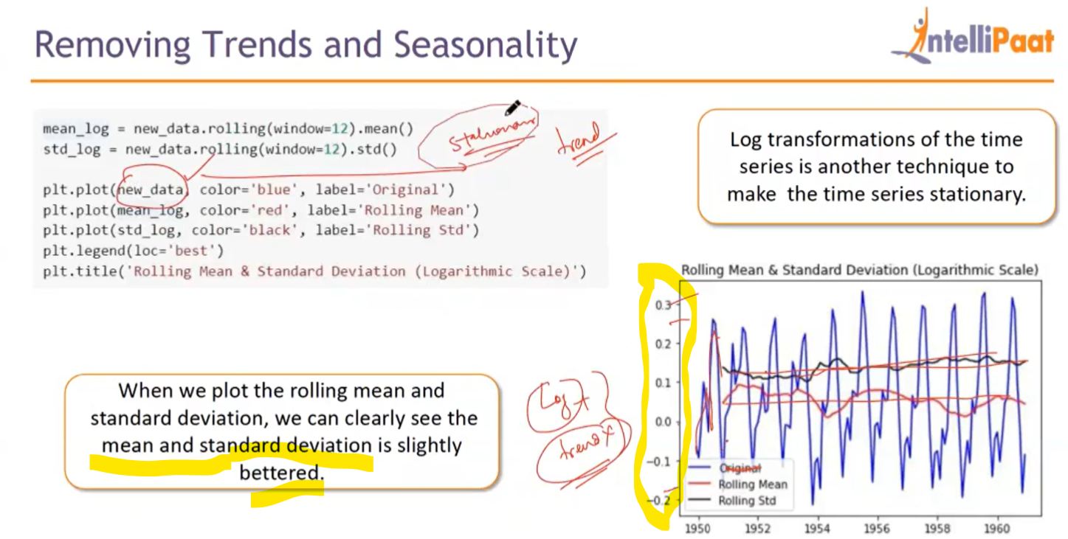
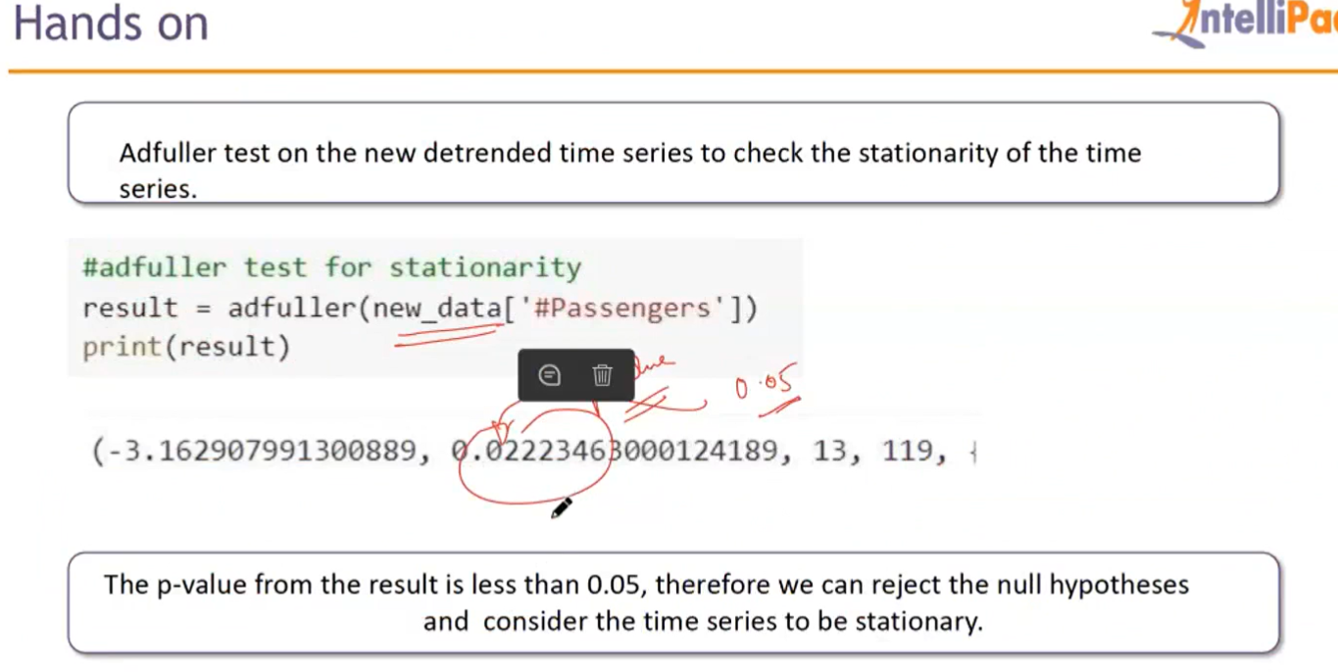

Another tool helps to split the trend, seasonal separately , now we could see in new_data trend removed(no positive or negative trend persist), but seasonality still persist :
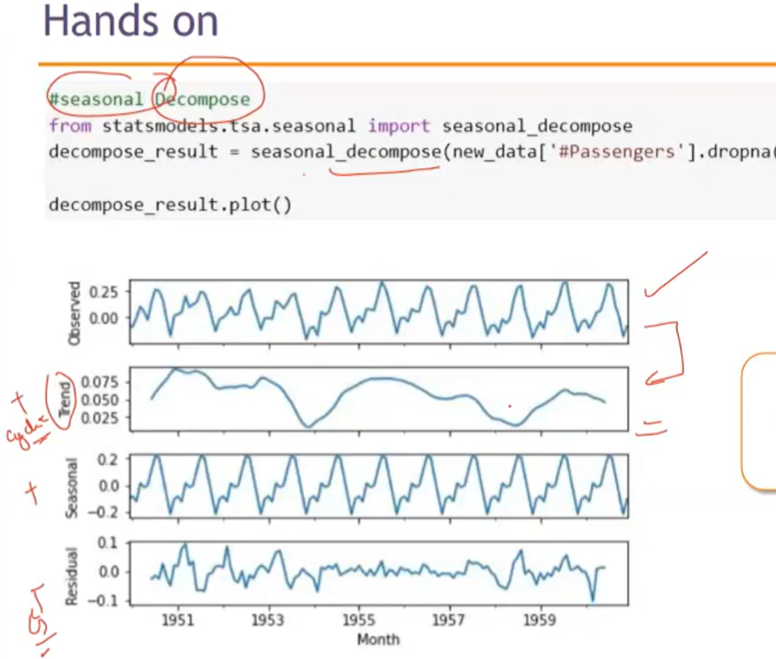
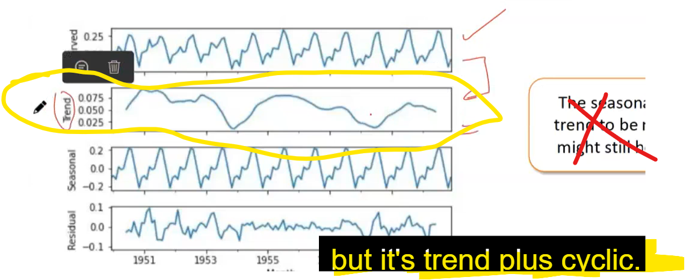

Seasonal_decompose tool just separate the different patterns (trend + cyclic, seasonal), so we could use this result, directly to remove the patterns from observed data, just reducing the decompose_results from original data, we could remove the trend, seasonal patterns.

- At last, before modeling , to know ARIMA(AutoRegressive+Integrated+Moving Average) , see what is Auto-correlation and Partial Auto-correlation:

Correlation : explains relationship b/w 2 variables.

Correlation Coefficient (Person’s) : A correlation coefficient (like Pearson's r or Spearman's rho) is a numerical value that quantifies the strength and direction of the relationship. Value b/w -1 to 1; -1 : strong negative correlation, 1 : strong positive correlation , 0 : no correlation at all.
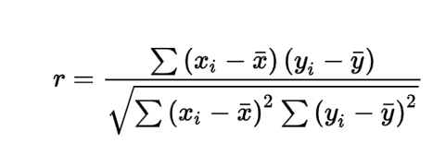

Auto-correlation (or Lagged Correlation): correlation b/w the current value and lagged value(past value) of same variable. Coefficient for auto-correlation formula derived from the same person’s coefficient formula: (here t is current point, k- how many points need lag, i.e which past value need to be consider to check the correlation. In below, k set as 1):
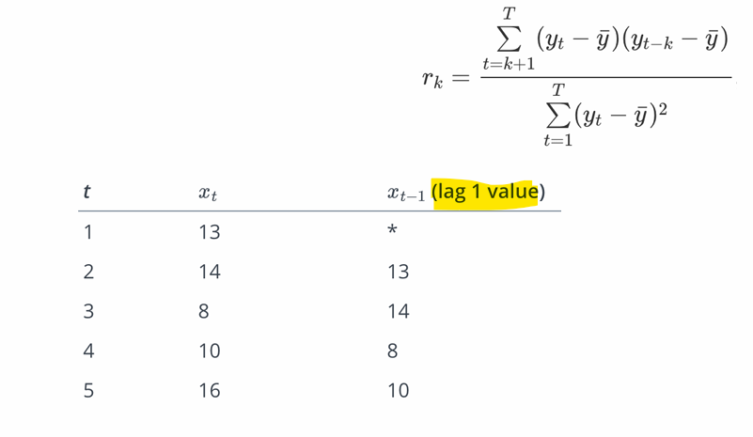
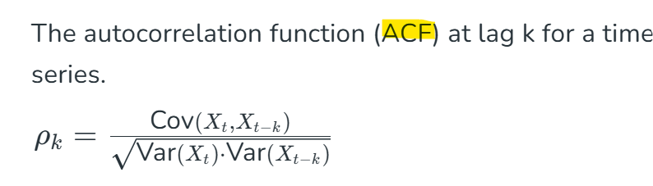
However, Autocorrelation(ACF) - "Total influence" :
- Measures how correlated a time series is with a lagged version of itself.
- It includes both direct and indirect effects of lags.
Partial Auto-correlation – “Direct influence only”, i.e. measures the correlation between today and a past value after removing the effects of all intermediate lags.
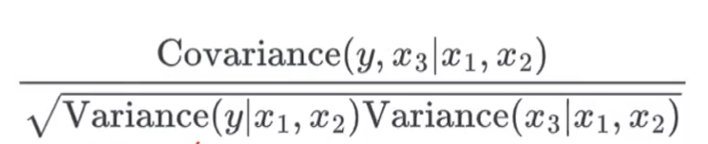

When to Use ACF(Auto-Correlation Function)/PACF:
- ACF helps identify MA (Moving Average) terms.
- PACF helps identify AR (AutoRegressive) terms.
For example, in ARIMA modeling:
- PACF drops off or shuts-off (in plot)→ Choose AR order
- ACF drops off (in plot)→ Choose MA order

ACF plot: when k=0 , yt=yt, so correlation always one. The noise with in the significance value 0.05 not significant (treat like 0). This noise called as white-noise.
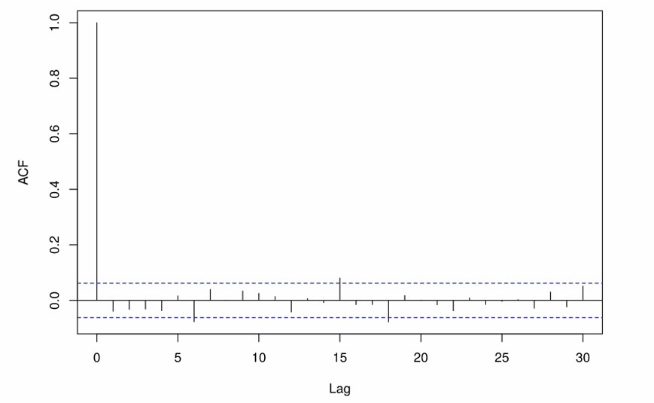

Partial autocorrelation :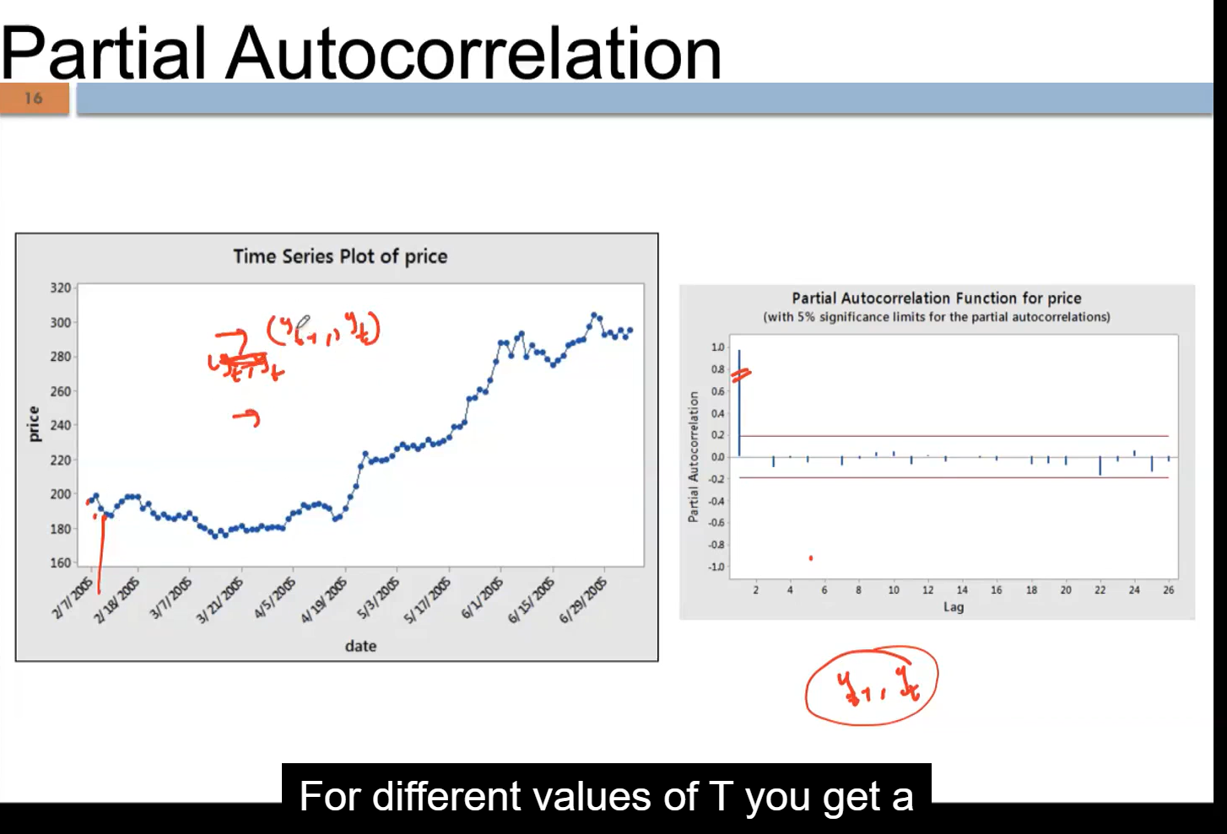

In below, right side graph with different Lag (k) values and its partial autocorrelation function value. But we could see the k=1 (i.e. lag1) has statistically significant, all other are just in white noise. Below linear correlation plot (x-axis =lag1price i.e. yt-1; y-axis=current-price i.e yt) also proves the same:
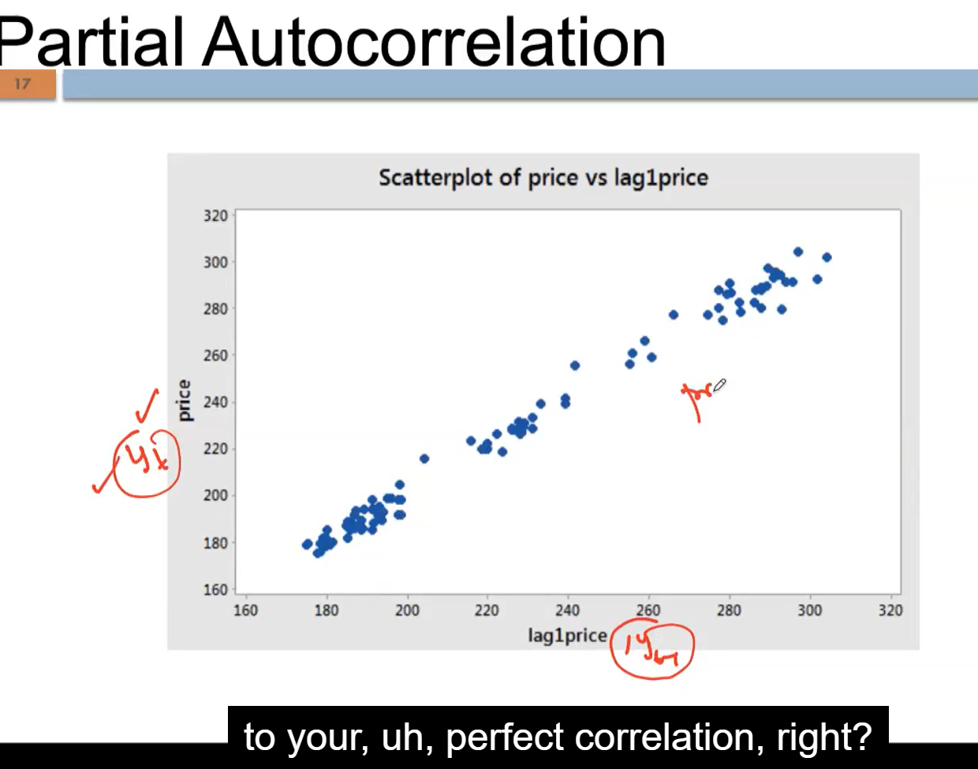

AR – Auto regressive model :
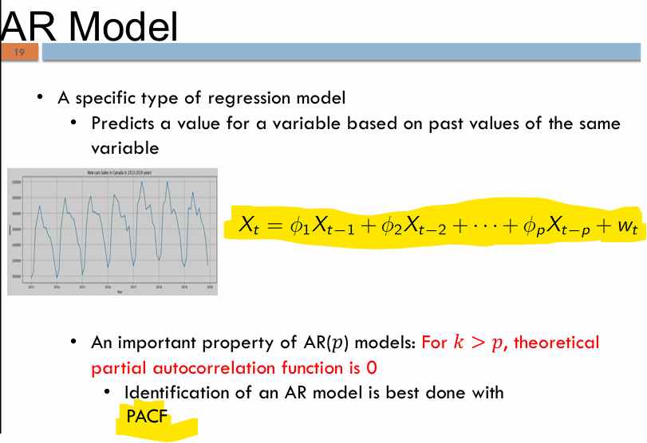

Below time series data can be modeled using AR(1) model : since PACF plot shows the sudden fall (shuts off) , and ACF gradual correlation fall, this data can be model using AR, not MA. And k=1 (lag1) gives the statistically significant correlation , and no other significant rise after that, it should be modeled as AR(1) process, and lag-1 correlation value is 0.9 , so the parameter (or pi) value will be 0.9, this is parameter value is learned from the process:
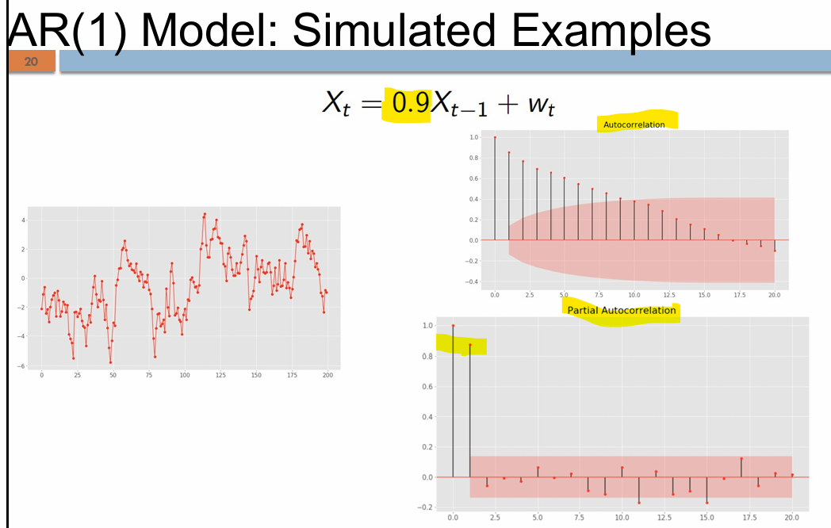

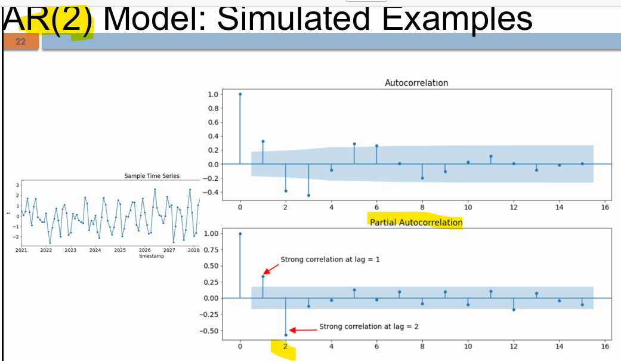
An important property of AR(𝑝) models: For 𝑘>𝑝, theoretical partial autocorrelation function is 0. In above plot , for all k values which are grater than 2 , the correlation is not statistically significant i.e. less than 0.05, i.e just white noise. Here , we see this 𝑘>𝑝 is satisfied.

MA (moving average) model : key difference is past epsilon (error/residual) values used instead of past values.
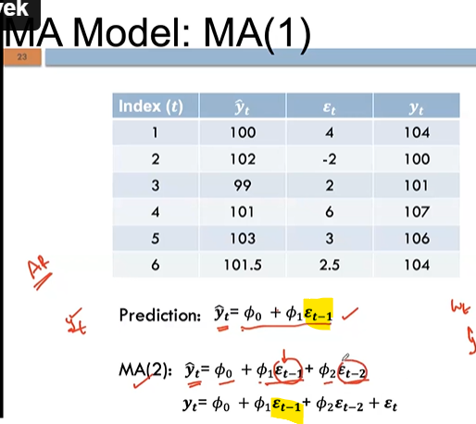pi0 will be 100 , the first predicted value.
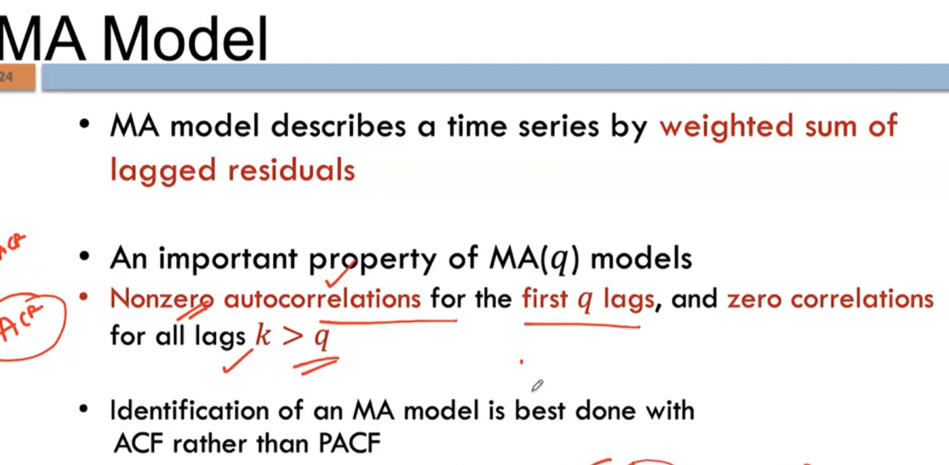

In below acf plot, K=1 most significant value , and satisfies k > q are zero. So MA(1) modeled.
And parameter not derived from acf value like AR, need to use optimization technique (like least square optimization) to define parameter(0.8).
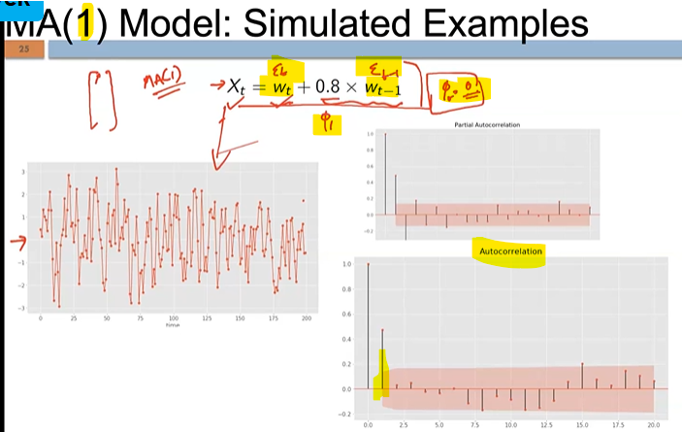
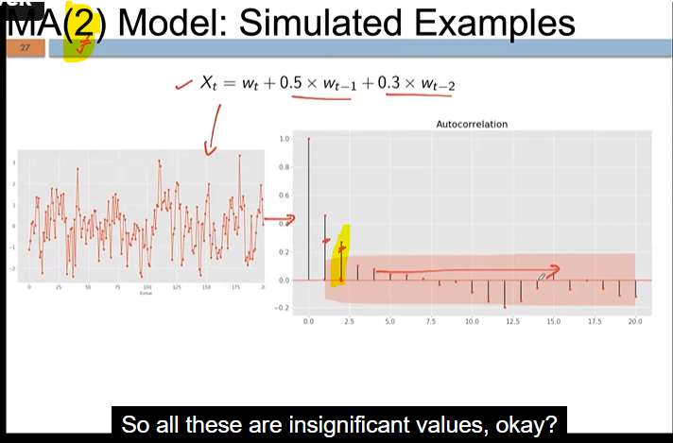

For below data ACF gradual decreasing, PACF shuts-off after k=1, so AR(1) process used to model the data.
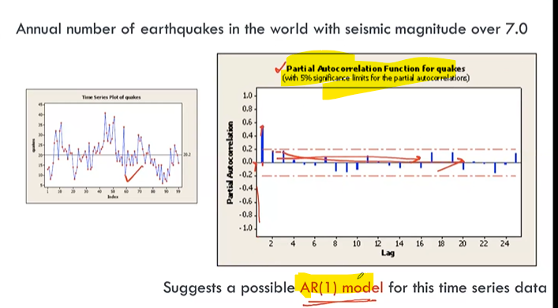
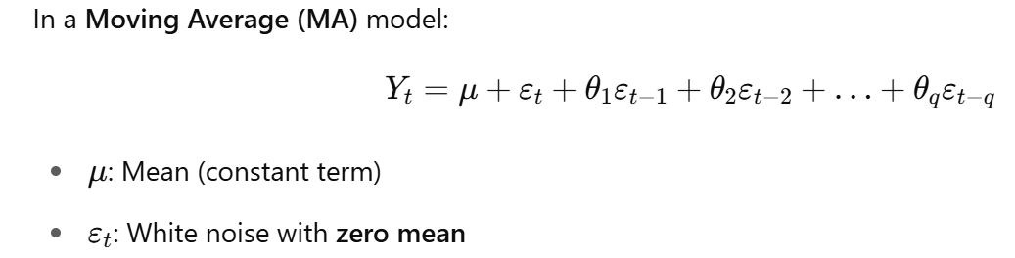
ARMA model: here wt is epsilon-t or error on t-sample. Deta-0 is mean, mostly mean is 0:
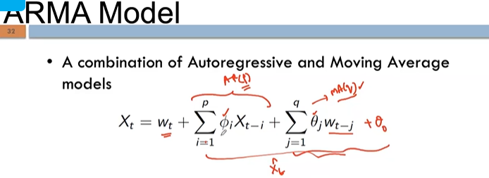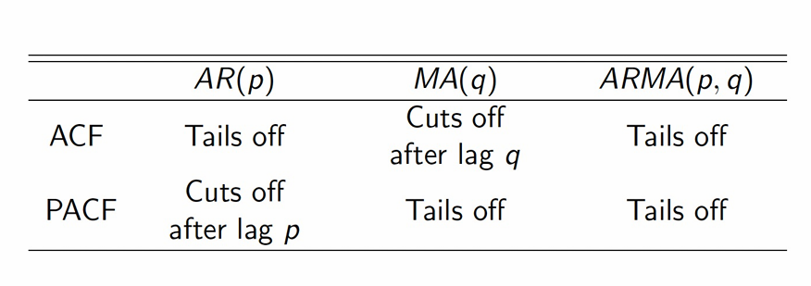cuts off = shuts off.

ARIMA model : (p, d, q) : d – since differencing is already done it is zero. Else 1 to n to define the differencing. RSS(1.50) is high, so poor model.
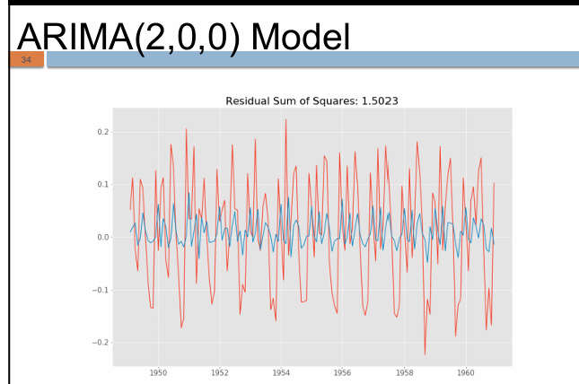

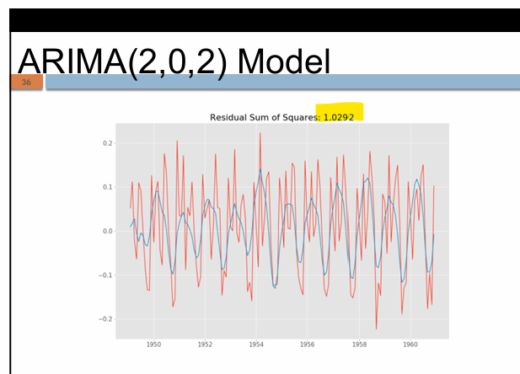
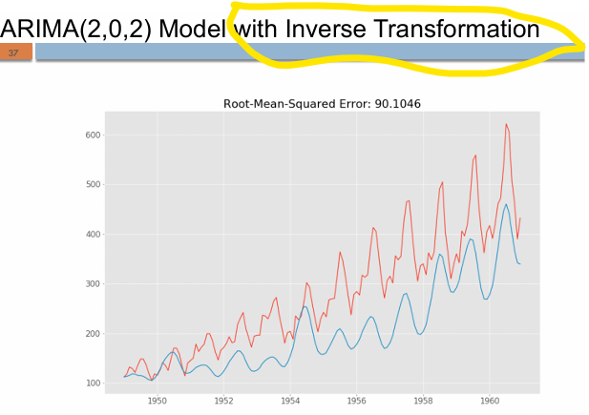blue -predicted

AIC – type of Information criteria.
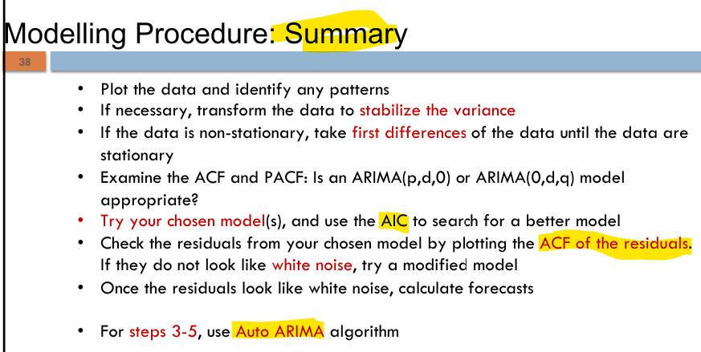
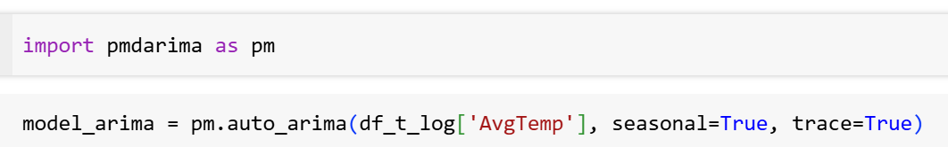
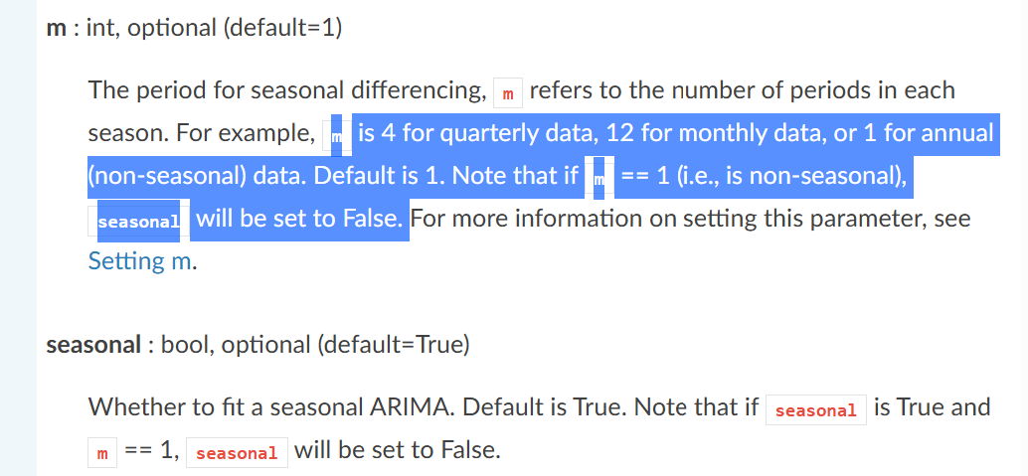

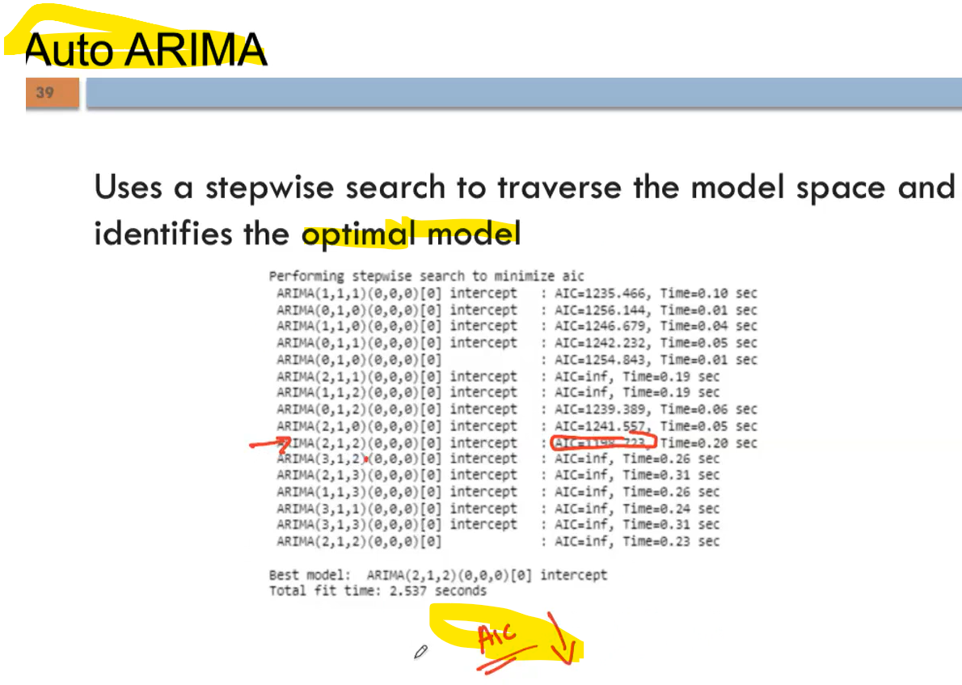

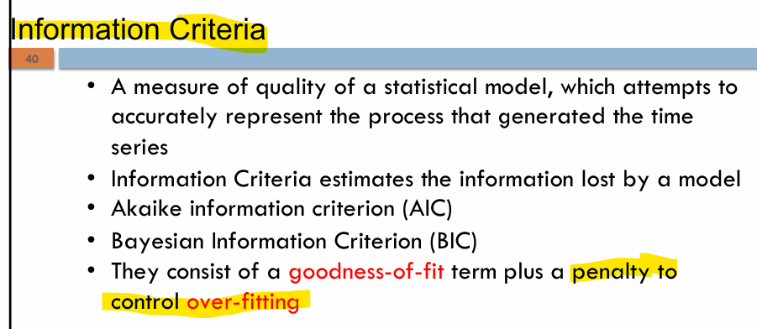

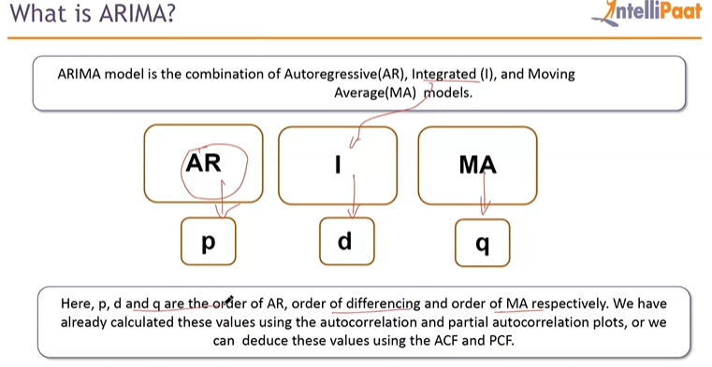
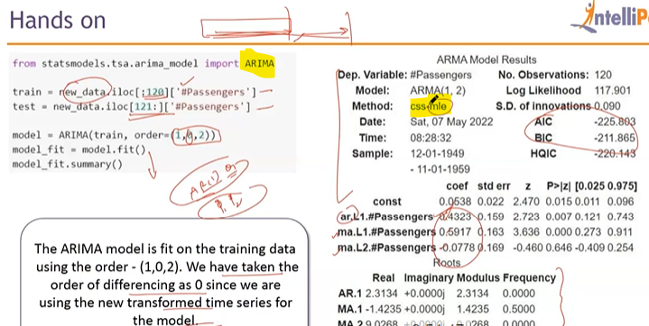

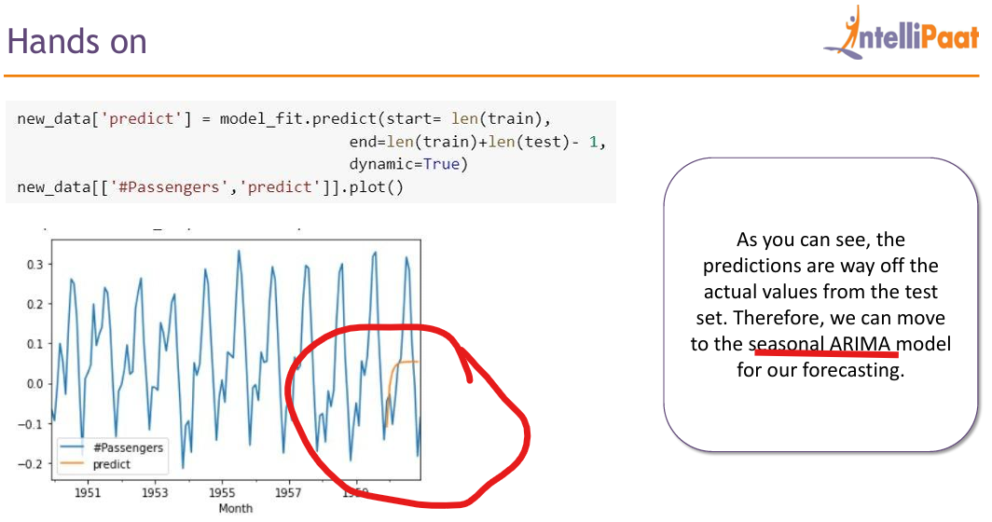
Model is poor , so move to SARIMA .

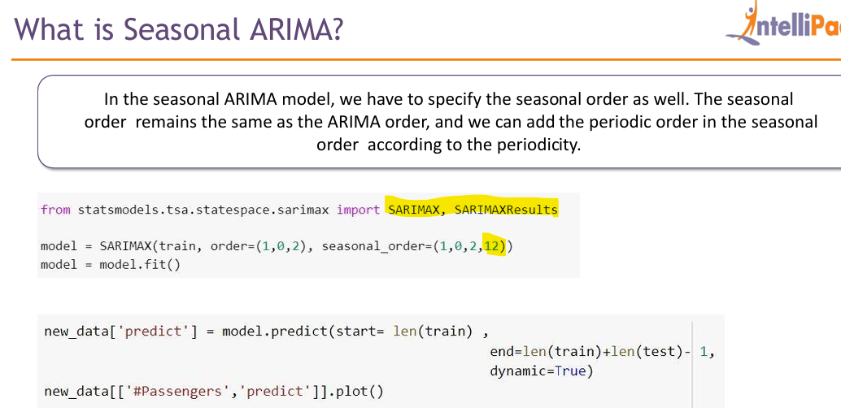
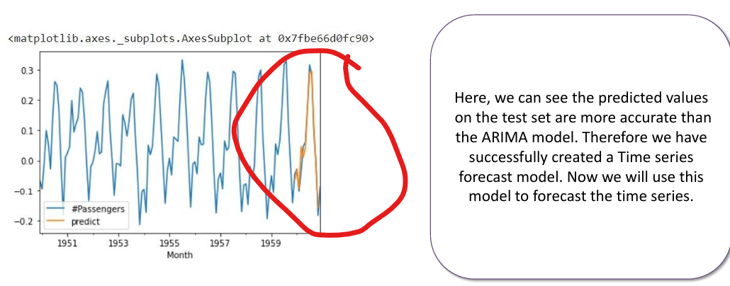
- Forecasting below :
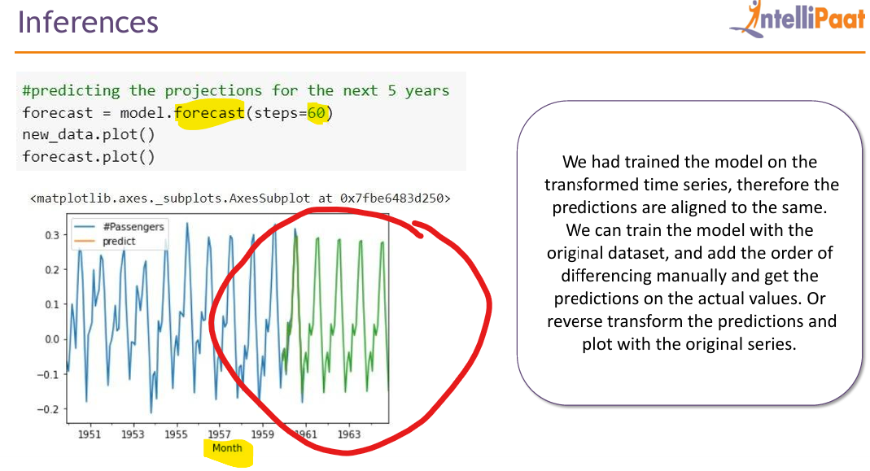
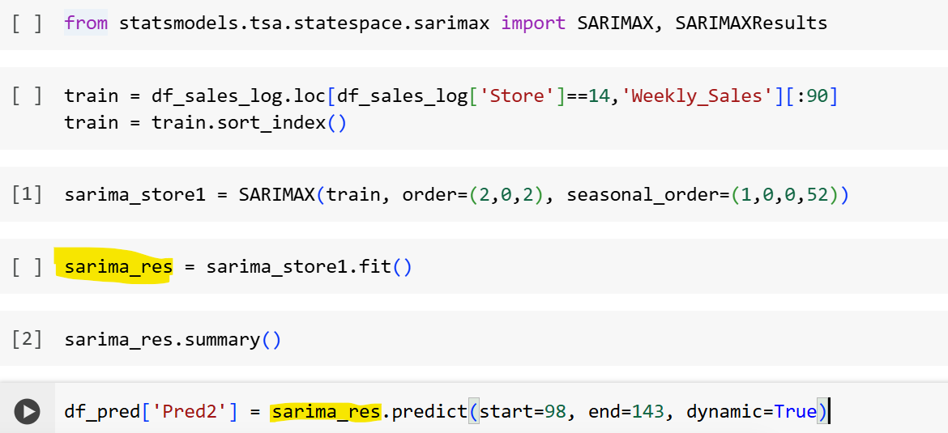
Use start-date and end-date which time frame need to predict:
Notes :
• Stationary time series show quick decay in ACF. (remember ADFuller statistical test (hypothesis test) is commonly used to check stationary or not).
• If no decay, it suggests non-stationarity — ACF remains high → trend or seasonality.
ADF vs ACF don’t confuse.

